This sticker appeared on Lancaster University campus and prompted the response shown.

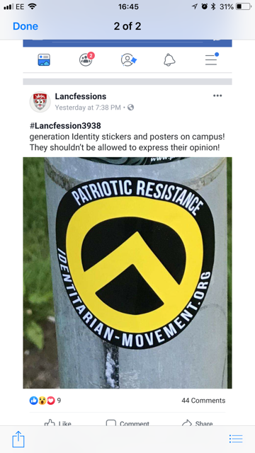

The images below are of stickers found by our Police Colleagues in Lancaster city centre on 13/6/19 – they were posted all along King Street. There was also one posted on Lancaster University campus.

It is believed they will have been posted by a local ‘Anti-fascist Action’ group, who are very vocal anti-nazi’s locally. There are quite a few Antifa in Lancaster, who host music events at a pub in town. This may be in response to a ‘Traditionalist Society’ that has been trying to set up at Lancaster University.

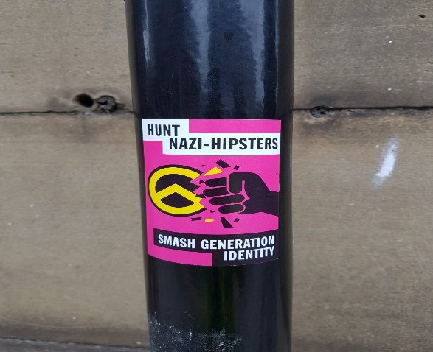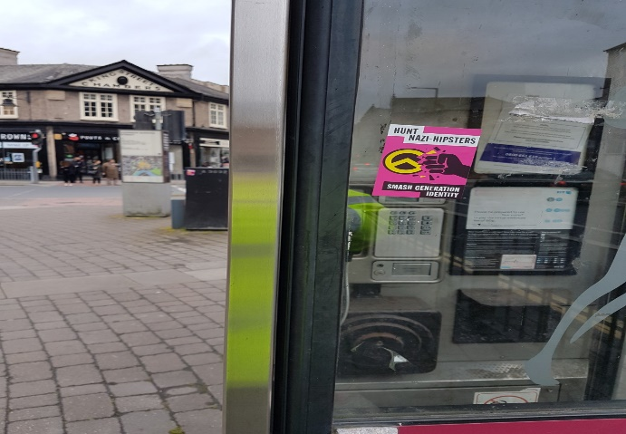

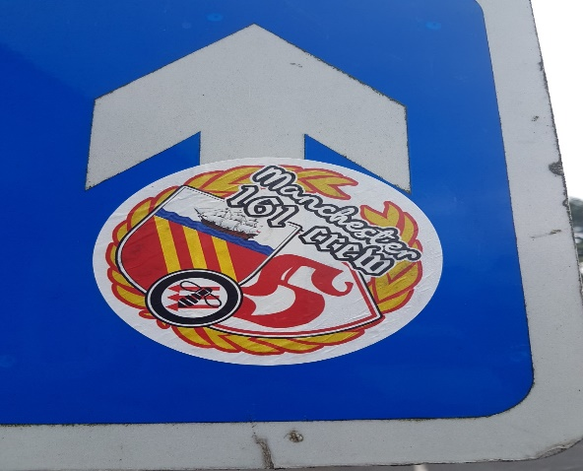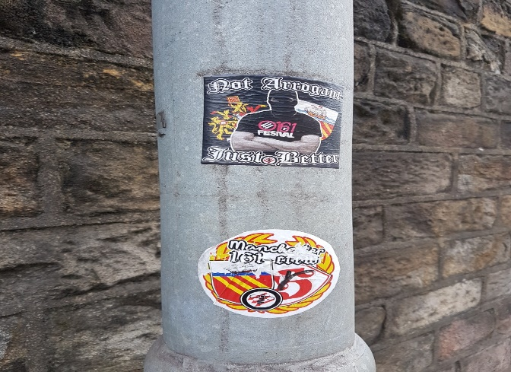

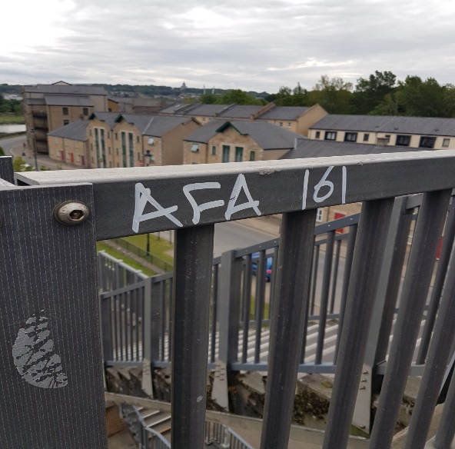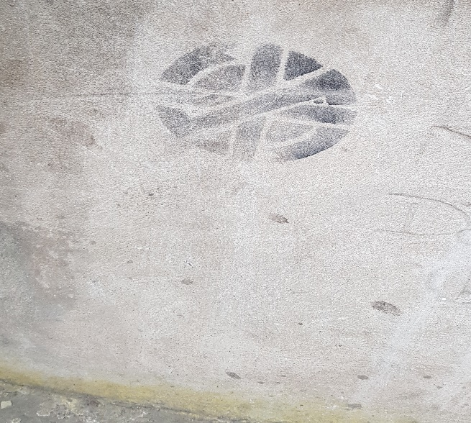

The above logo is from a band called crass who were a punk band in 1970s – they promoted direct action, animal rights, feminism, anti-fascism, and environmentalism and used to spray that symbol on the London Underground. It was used as an antifacist symbol (something that the band was also in favour of) sometimes the symbol was accompanied by the slogan: fight war not wars…

