Safety When Travelling
Plan ahead
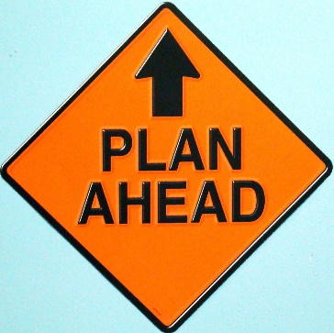
Before you go out, consider how you are going to get home, e.g. Can you travel home with a friend? What time does the last bus/train leave?
Prepare for your day before you leave – consider what you might need.
Update someone on your plans.
Consider carrying a personal alarm.
Plan your journey – google street view is particularly useful for identifying landmarks in an unknown area.

When travelling on foot
Try to use well-lit, busy streets and use the route you know best.
Plan your route, and look confident as you travel.
If you do have to pass higher risk areas, consider what how you’d respond if you felt threatened.
Consider heading for a public place; somewhere you know there will be other people, for example a garage or shop.
Whenever possible, walk facing oncoming traffic to avoid curb crawlers.
If you think you are being followed, trust your instincts and take action. As confidently as you can, cross the road, turning to see who is behind you. If you are still being followed, keep moving. Head to a busy area and tell people what is happening. If necessary, call the police.

Remain aware
Keep your mind on your surroundings – avoid distractions such as your mobile phone or headphones.
Be aware when using cash point machines. If there are signs of tampering or people acting suspiciously, do not use it.
Try not to keep all your valuables in one place. It’s a good idea to keep valuables such as wallets in an inside pocket.
Consider carrying a personal safety alarm, which can be used to shock and disorientate an attacker giving you vital seconds to get away.

Mode of Travel
Travelling by train, bus or taxi/minicab is generally very safe but violent and aggressive incidents do happen, so it makes sense to take a few simple precautions to improve your safety and increase your confidence.
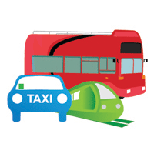

Taxis and Minicabs
Taxis (Hackney Carriages) can be hailed in the street. They look like purpose–built taxis or black cabs and have an illuminated taxi sign on the roof.
Licensed minicabs cannot be hailed in the street. They must be pre-booked. The driver should have ID and the vehicle will have some sort of license displayed on it.
Always carry the telephone number of a trusted, licensed company with you.
When booking a taxi or minicab, ask for the driver's name, as well as the make and colour of the car. Confirm the driver’s details when they arrive – is it the taxi or minicab you ordered?
Sharing a taxi or minicab with a friend and sitting in the back of the car are good safety strategies.
If you chat to the driver, be careful not to give out any personal details.
Remember - Minicabs that pick-up fares on the street, without being pre-booked, are illegal, uninsured and potentially very dangerous.
If you feel threatened:
Trust your instincts - If you are at all worried, ask the driver to stop in a busy area and get out of the car.
If the driver refuses to stop, use a mobile (if you have one) to call the police and alert other drivers and pedestrians by waving or calling out the window.
Cycling Safety
Keep your bike in good working order. Repairs are best done at home rather than on the road.
Always look like you know where you are going.
Dress to be seen and to be safe. Remember to wear a safety helmet.
Obey the rules of the road and make sure you are aware of your surroundings.
Avoid short-cuts even if you are in a hurry. Never cycle anywhere you would not be comfortable walking.
On Public Transport
Know where you are going and which stop you need.
Check departure times, especially of last buses or trains.
Try and have your ticket, pass or change ready in your hand so your purse or wallet is out of sight.
If travelling at night or in an unfamiliar area, try and arrange for someone to meet you at the bus stop or train station. Otherwise try to walk near other people with whom you feel safe, and walk purposefully to your destination.
Wait for a bus or train in a well-lit place near other people whenever possible.
Carry extra money in case you get stranded and need to take another bus, train or cab.
If a bus is empty or it is after dark, it may be safer to stay on the lower deck and sit near the driver.
On trains avoid compartments which have no access to corridors or other parts of the train. Try to sit with other people and avoid empty carriages.
If you feel uneasy, move to another seat or carriage. If you feel threatened, make as much noise as possible to attract the attention of the driver or guard.
With thanks to the Suzy Lamplugh Trust. Visit https://www.suzylamplugh.org/ for further information.

