Internet Risks

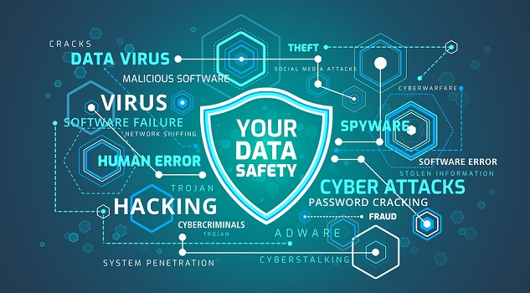
Social Networks
- Avoid sharing your personal details such as your address, phone number, routine or place of work
- Review your privacy settings to make sure that only your friends can see your profile details and pictures
- When posting about your life, or with someone online, talk about where you’ve been rather than where you’re going
- Add people that you know, as contacts or friends
- Do not share your passwords with anyone- If you think you may have revealed it accidently, change the password as soon as possible
- Try to use memorable hard to guess passwords, such as a phrase or fact, rather than using the automatic log-in function offered on some browsers, and change them regularly

Online Dating and Forums
- Consider creating a username that doesn’t reveal too much about yourself
- Avoid being too specific on your profile about where you work, where you live, or your surname, and don't include your phone number
- Consider using a new email or lesser used email address when setting up an account, one that if hacked, does not have all your bank details, shopping accounts, contacts etc.
- When chatting with someone online it’s better to talk about where you’ve been rather than where you’re going
- Keep the conversation online- Many dating website and forums will have rules to protect users from people using the site incorrectly
- If you decide to meet someone you know online, arrange to meet in a public place and ask a friend to come with you at first
- Turn off your geo-location tags on your phone, before sending images to someone else (some mobile phones and digital cameras automatically attach data to the photo file that identifies where the picture was taken, so turning this function off helps you to avoid a situation where someone you met online, might be able to trace your movements)

Computers, laptops and tablets
- Install anti-virus and anti-spyware software if required, and make sure it’s up to date
- Try to use memorable hard to guess passwords, such as a phrase or fact, and update it regularly
- Avoid saving sensitive information to your desk top- If your device is stolen or lost, it could be very easy for someone to access this information
Email
- Use a memorable hard to guess password, such as a phrase or fact, and update it regularly
- Consider creating different email accounts to use with financial services and retail accounts
- Consider setting up a filter so that junk emails are removed, and emails from a particular sender go straight to a certain file and don’t appear in your inbox
- If someone gains unauthorised access to your email, change your password as soon as possible
Mobile phones
- Set up a PIN number to unlock your phone. Use random numbers instead of birthdates or other guessable formats
- Try to set it to lock after one or two minutes without use
- Carry a charger wire or portable charger to make sure you are topped up when required
- Avoid saving any personal/sensitive information on your phone
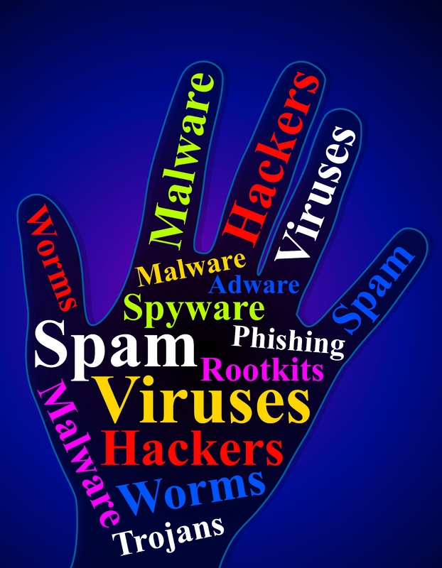
- Consider turning off geolocation services in camera apps and your mobile settings.
With thanks to the Suzy Lamplugh Trust. Visit https://www.suzylamplugh.org/ for further information.

