Healthy Eating
Eating a healthy, balanced diet is an important part of maintaining good health, and can help you feel your best. This means eating a wide variety of foods in the right proportions, and consuming the right amount of food and drink to achieve and maintain a healthy body weight.
In order to have to have a healthy, balanced diet, people should try to:
- eat 5 portions of fruit and vegetables a day
- base meals on starchy foods like potatoes, bread, rice or pasta
- have some dairy or dairy free alternatives (such as soya drinks)
- eat some beans, pulses, fish, eggs, meat and other protein
- choose unsaturated oils and spreads, eaten in small amounts
- drink plenty of fluids
If you're eating foods and drinks that are high in fat, salt and sugar, have these less often and in smaller amounts. Most people in the UK eat and drink too many calories, too much fat, sugar and salt, and not enough fruit, vegetables, oily fish or fibre.

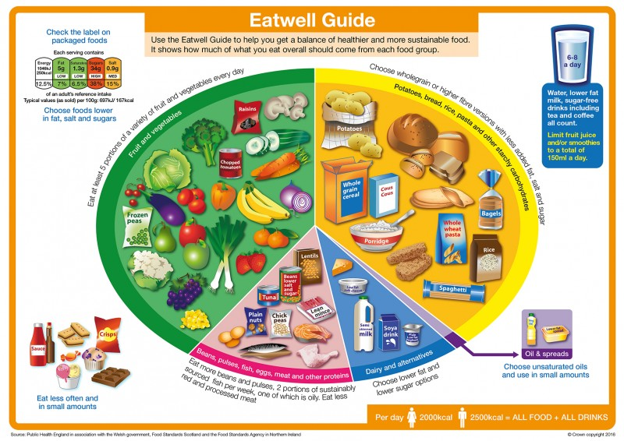
The Government’s Eat Well Guide can be found here

